**ANNEX J**

**DESIGN OF NEGOSYO SA KARITON (NEGO-KART)**

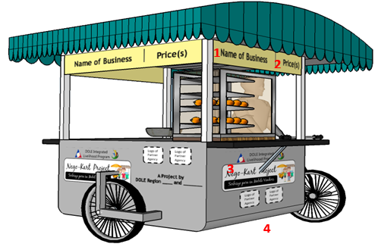

**LEGEND**

1. Name of Business or Beneficiary
2. Services and Price(s)
3. DILP and Nego-Kart Logo
4. Logo of Partner-Agencies

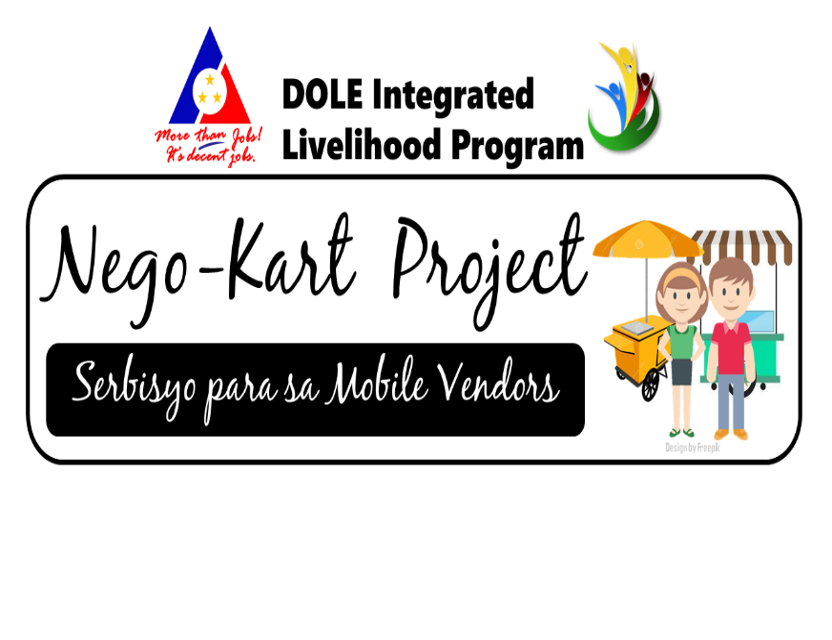

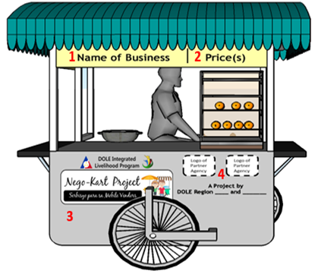

**LEGEND**

1. Name of Business or Beneficiary
2. Services and Price(s)
3. DILP and Nego-Kart Logo
4. Logo of Partner-Agencies